Remote Monitoring System: Usage Instructions

Note: An 8 Amp inline fuse is recommended when connecting instruments to be monitored

All Source Code will be available at: https://github.com/aannuzzi/remote-monitoring

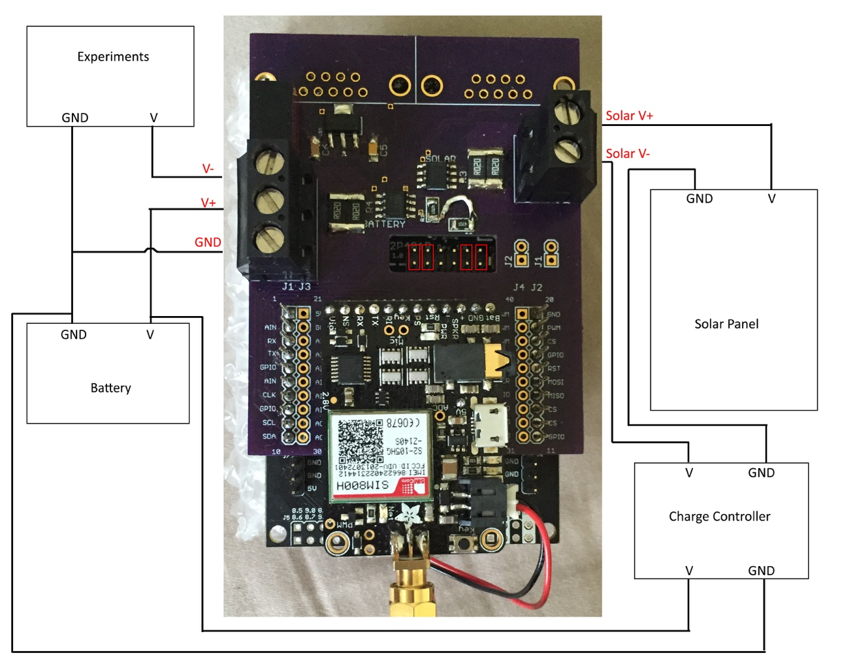

**Setup:**

* Both measurements being taken must share a common ground
* The measuring device is to be in series with the positive side of the device being measured
* A typical setup image is included above
* Ensure the programming jumpers are removed (red boxes in image)

**Specifications:**

Maximum Voltage (V- to GND): ± 26 V

Maximum Current: ± 8 A

VCC: > 6.5 V

**Programming:**

1. Download Energia (<http://energia.nu/>)
2. Get the source code from the msp432 directory of the github.
3. Ensure power is disconnected from the device.
4. Connect the jumpers as shown in the picture above.
   1. The left two are required, the right two are for debugging
5. Connect the USB cord and click the Upload button in Energia